Milk Crate Theatre Online Program 2020

BASICS SERIES – 03

WAKE UP SHAKE UP!

CHECK IN WITH YOUR BODY
Please only do what feels good for you here.
There is no need to push or force any of these movements. They are just to wake up your body a little, and it should feel good.
If you have any injuries, only do what you can today.

Jog on the Spot

Engage your tummy even though you are being loose!

Shake out the shoulders and arms while you jog
Keep jogging, and take your arms:
- Up
- Out to the sides
- Down next to you
- Out forward

Keep changing and play with any combination of these!

Come to stillness.

Neck

TILT SIDE TO SIDE
Tilt the head gently to one side – ear towards shoulder.
Repeat on the other side, keep changing side to side.

Take it easy here – there is no need to try to touch your ear directly to your shoulder!
Just a nice gentle tilt to wake up the sides of the neck, like “Oh hey neck!”

TURN SIDE TO SIDE
Now turn your head side to side, looking left, looking right.
Repeat

LOOK UP AND DOWN
Now move your head to look up and look down
Repeat
Again, take it easy and don’t try to stretch or strain too far, especially when looking up

Bring your head back to centre.

HALF HEAD ROLL
(Do not do a full head roll!)
Tilt your head to the right hand side and take a gentle half roll towards the front, until your head is tilted to the left. Circle back to the right, and circle back to the left.

Shoulders and Arms

SHOULDER ROLLS
Roll your shoulders – forward, up, back, and down – forward, up, back, and down

Incorporate a gentle bounce in the knees

ELBOW CIRCLES
Now bend your elbows and bring your hands to your shoulders or arm pits for elbow circles – or chicken wings as I call them!

Keep a soft bounce in the knees

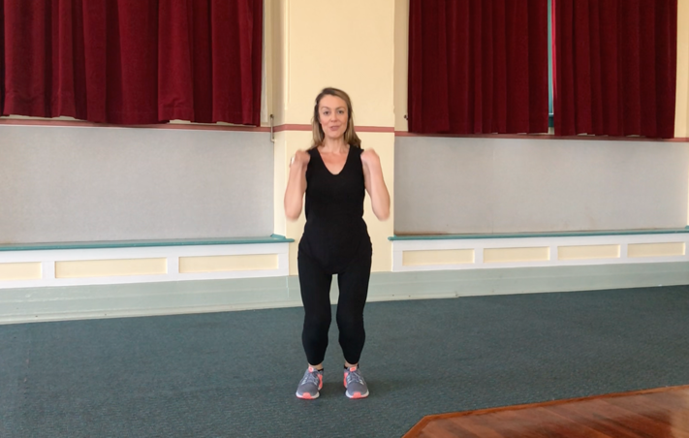

BIG ARM CIRCLES
Keep that tummy strong now because we are going to extend our arms and move them in big circles – it’s important we don’t strain our backs here!

So arms down to our sides, bring both arms forward and up, round to the sides, and back and down, swooping right into the next circle:
Forward, up, out, down and around to –
Forward, up, out, down and around …

Keep the tummy strong and stretch the arms out wide in all directions.

OPENING OUT AND CURLING FORWARD
Open up your chest to the sky with your big arm circle, really stretch out!
When your arms come down and forward, curl your body forward with them.

Bring your body up as your arms come up, and curl forward as they come down
Repeat

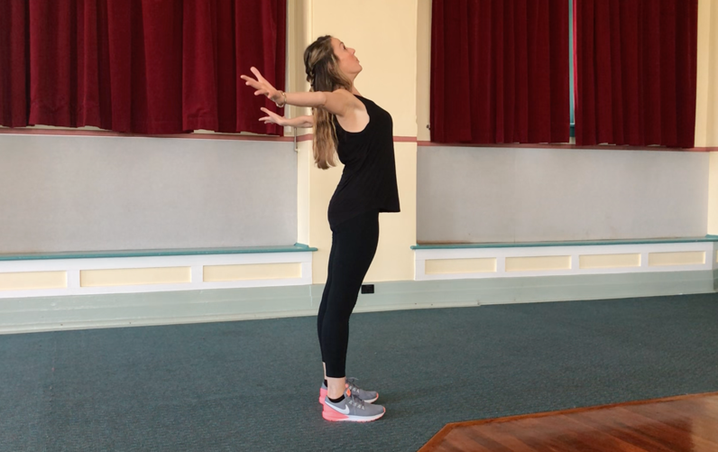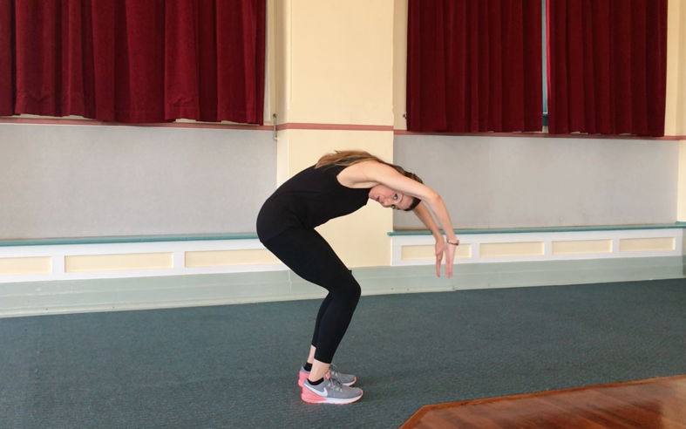

HANGING FORWARD
On your last one, stay relax forward. Soft knees, strong tummy so you don’t hurt your back.
Hang out here!
Arms hanging to the floor, nice soft neck – your head should hang!

If this is too much strain, stay upright, and simply tilt your head forward, bringing your chin a little closer to your chest
Or, curl your shoulders and body forward, without coming all the way down to folding forward

Strong tummy muscles to roll back up to a standing position.

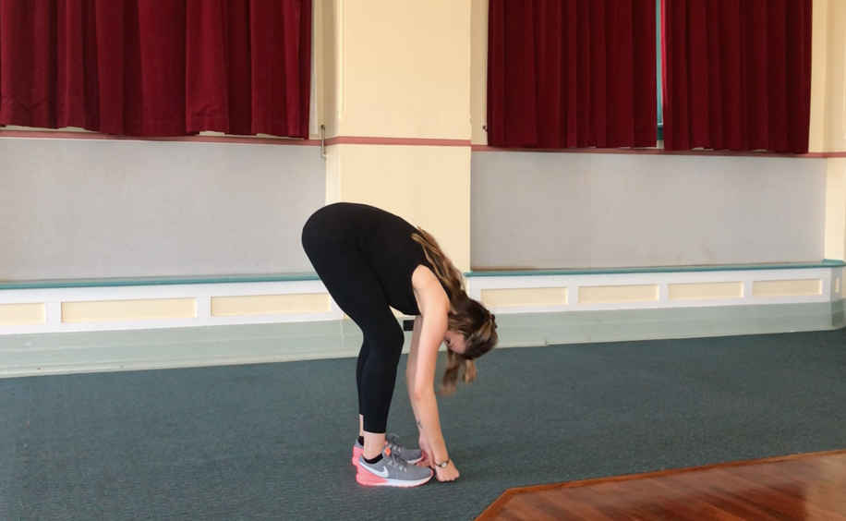

SPINAL ROLLS
Bring your hands together at your heart centre, and roll forward again until you are hanging forward.
Come back up to standing by tilting your pelvis forward, and rolling up through the spine, vertebrae by vertebrae – bit by bit – head come up last, and follow with your arms reaching up to the sky.

Repeat

FORWARD ARM SWINGS
Swing your arms forward, then down to the back – forward and back, forward and back.

Incorporate a knee bounce with this!
Every time your arms are by your sides, your knees are bent – when your arms are out in front of you or out behind you, your knees are straight.

See if you can take this momentum even further by bringing your upper body into the swing – so when your arms are down by your sides and your knees are bent, your body is hanging forward too.
Use your tummy and the momentum of the arm swing to bring you back up when the arms extend!

Repeat, and have fun!!

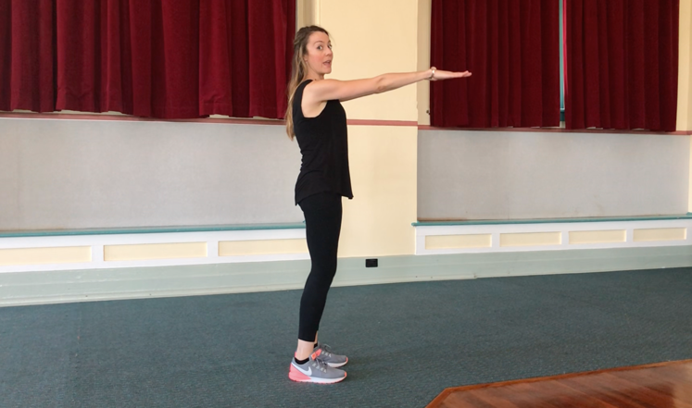

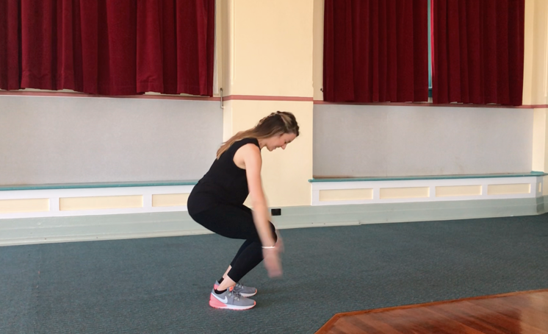

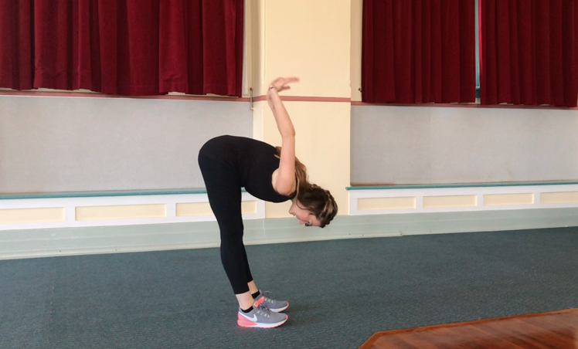

Torso

SIDE SWAY
Take your feet a bit wider than hip-distance apart, keep the knees soft.

Sway your body, turning side to side, letting the arms follow and swing across your body.
The movement needs to come from your torso, and the arms follow and flop around after you!

A nice gentle sway, side to side, that gives you a nice twist in the body.

Come to stillness.

Have a little shake out of the body.

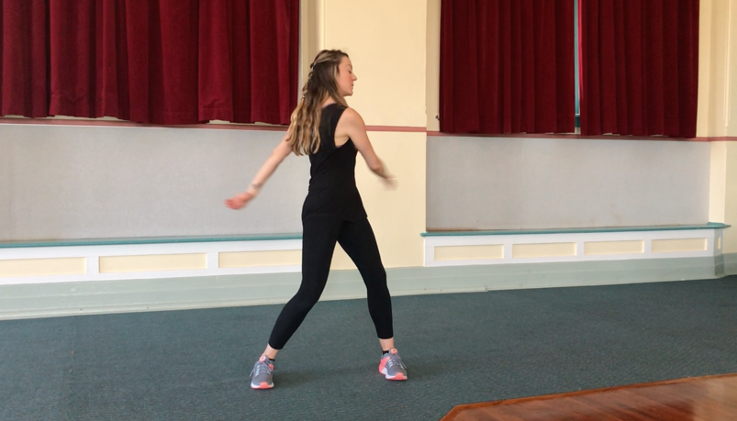

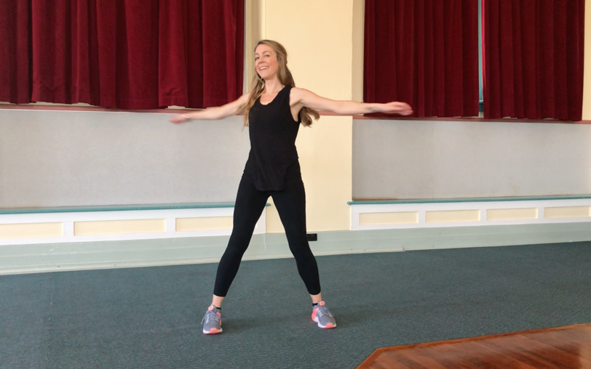

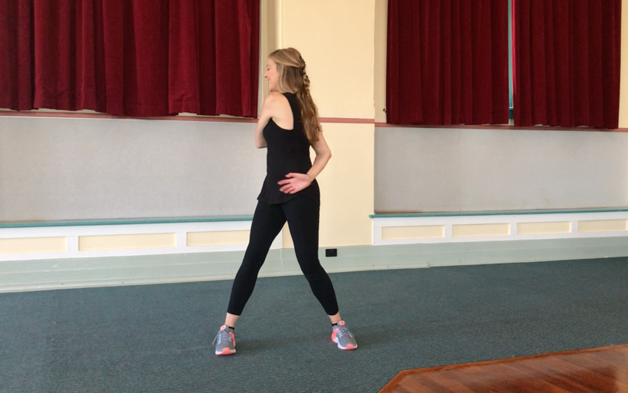

Shoulders

SHUT THE GATE and LOCK IT UP
Bring your right arm out straight in front of you in line with your shoulder.
Bring your left hand around to the outside of your right elbow.
Gently use your left hand to guide your straight right arm across the front of your chest.

The aim here is to keep the arm straight, not to see how far you can reach your hand.
You should feel a little stretch behind your right shoulder, near the shoulder blade.

Repeat on the other side!

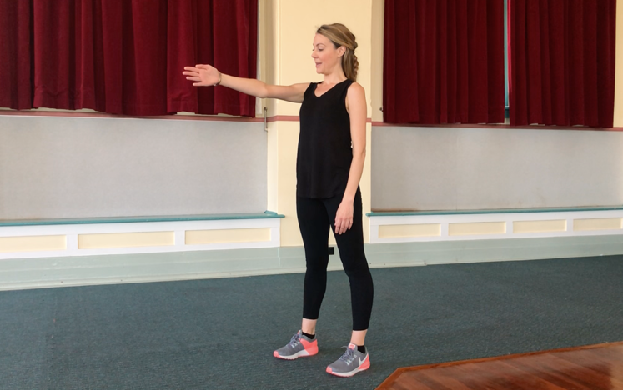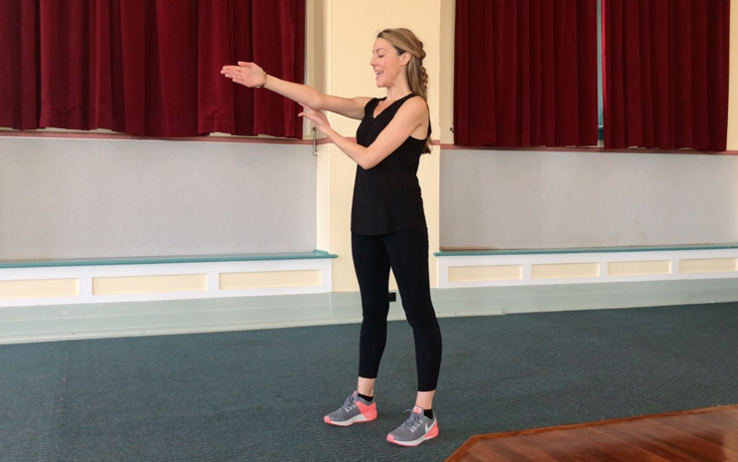

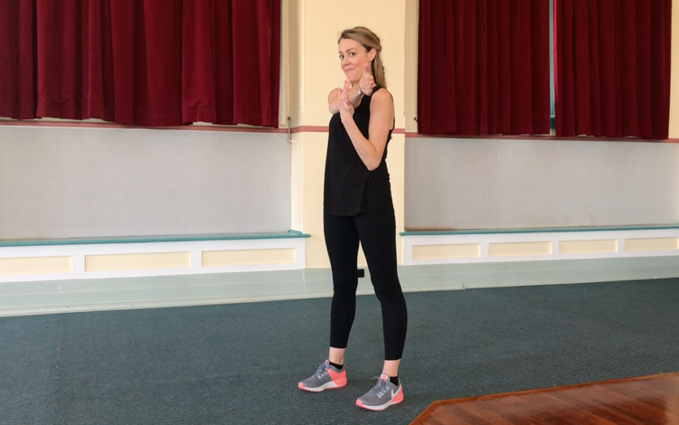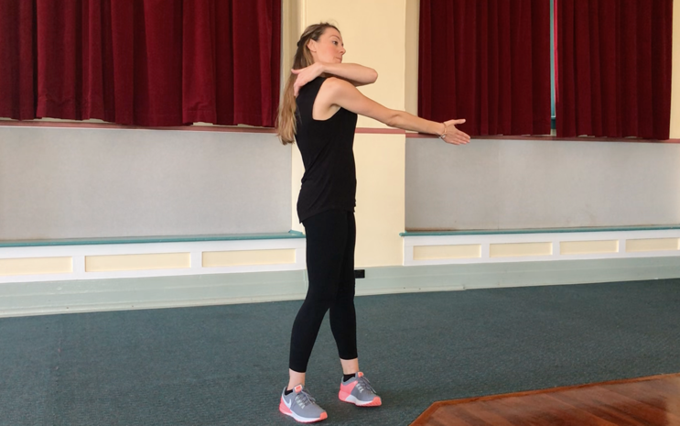

Finishing Up

DUSTING OFF
Use your hands to gently “dust off” your body from head to toe

Well done

