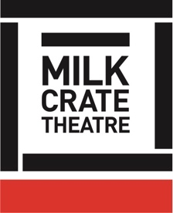
Milk Crate Theatre Online Program 2020

BASICS SERIES – 02

SEATED STRETCH

Please only do what feels good for you here.
There is no need to push or force any of these movements. They are just to wake up your body a little, and it should feel good.
If you have any injuries, only do what you can today.

If you haven’t done so already:

GETTING INTO POSTURE

Sitting upright in a chair
Have a little wriggle and let out all of the little micro-tensions in your body.

Sitting on the edge of the chair, with your feet flat on the ground, hip-width distance apart
Knees above ankles, so your knees, ankles, and hips all make a nice bunch of right-angles!

Imagine there is a little string coming out from behind your belly button out of your back –
Imagine pulling that string, and pulling in your tummy.

You should immediately feel your body naturally sit up a little bit taller, and maybe your chest lifts a little too.
Gently roll your shoulders back a couple of times to open up the chest.

Hands on knees or thighs.

Sitting nice and tall, strong tummy but not exerting too much effort or being rigid about it.
Focus on your tummy strength and this will prevent building tension in your back.

Just feeling nice and strong and tall, from your bottom bones on the chair, up through your body to the tip of your head.

DIGNITY - This is a dignified and strong physical position!

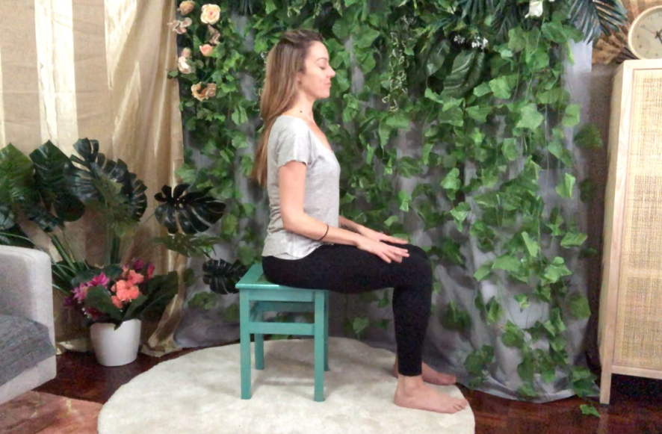

UPPER BODY

Strong tummy, sitting tall

NECK STRETCHES
Tilt the head gently to one side – ear towards shoulder.
Repeat on the other side, keep changing side to side.

Take it easy here – there is no need to try to touch your ear directly to your shoulder!
Just a nice gentle tilt to wake up the sides of the neck, like “Oh hey neck!”

Now move your head to look down and look up
Repeat
Again, take it easy and don’t try to stretch or strain too far, especially when looking up

Now turn your head side to side, looking left, looking right.
Repeat.
Bring your head back to centre.

Tilt your head to the right hand side and take a gentle half roll towards the front, until your head is tilted to the left. Circle back to the right, and circle back to the left.

HALF HEAD ROLL ONLY! (Do not do a full head roll!)

SHAKE
Shake out, roll your wrists around, and your ankles one by one.

SHOULDER ROLLS
Roll your shoulders – forward, up, back, and down – forward, up, back, and down

ELBOW CIRCLES
Now bend your elbows and bring your hands to your shoulders or arm pits for elbow circles – or chicken wings as I call them!

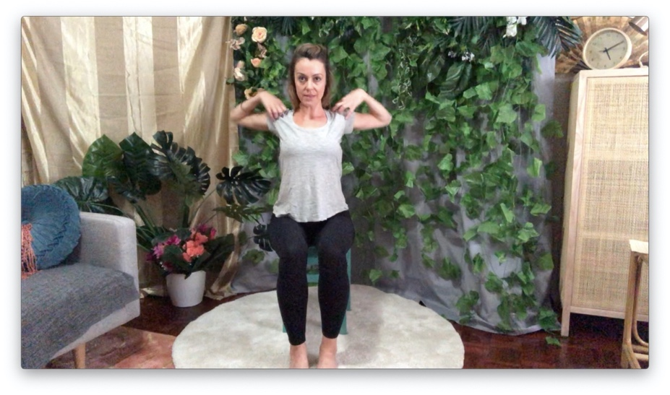

BIG ARM CIRCLES
Keep that tummy strong now because we are going to extend our arms and move them in big circles – it’s important we don’t strain our backs here!
So arms down to the sides of our chair, bring both arms forward and up, round to the sides, and back and down, swooping right into the next circle:
Forward, up, out, down and around to –
Forward, up, out, down and around …

Release the arms.
Breathe.

TORSO

Strong tummies!

CURLING FORWARD
Do one more big arm circle, and this time, let your body curl forward as you bring your arms down
Bring your body up as your arms come up, and curl forward as they come down
One more time coming up, and this time as you come down, relax forward.
Face between your knees, tummy on your thighs, shoulders resting on your knees, arms hanging to the floor, nice soft neck – your head should hang!

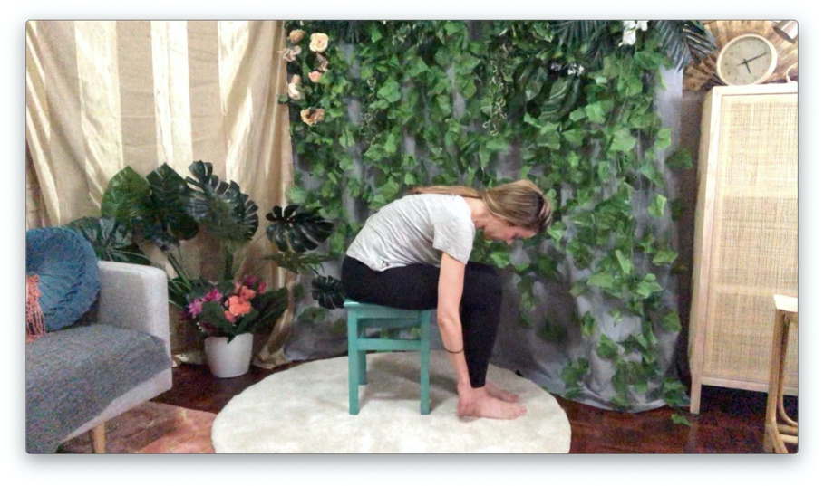

If this is too much strain, stay seated upright, and simply tilt your head forward, bringing your chin a little closer to your chest. Or, curl your shoulders and body forward, without coming all the way down to folding forward

Hang out for a bit. Let your shoulders melt outward, and feel a lovely opening of the upper back …

Strong tummy muscles to roll back up to a seated position.

LOWER BODY

LEG STRETCH
Sitting at the edge of your chair, extend one leg out, as straight as possible.
Flex your foot (point toes toward yourself)
If this is enough of a stretch for you stay here.
If you would like to stretch a bit more, lean forward to fold over your thigh, reach for your foot.
Remember the aim here is not to reach for the foot! It is to feel a stretch in the back of your leg.

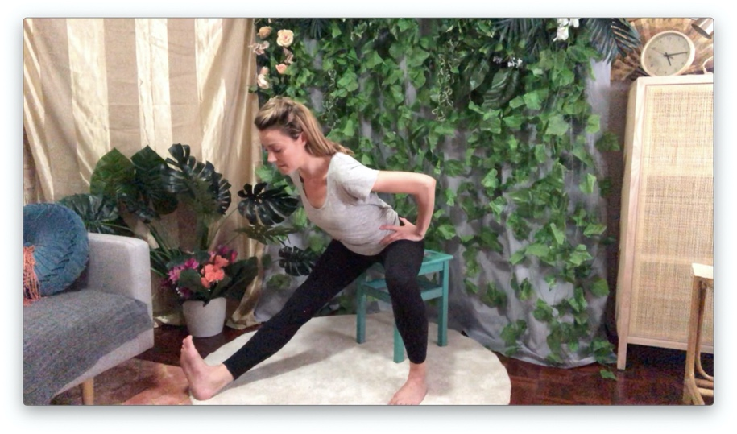

Release. Sit up.
Repeat with other leg.

HIP STRETCH
Sitting on edge of chair, feet flat on floor.
Turn one foot out to the side to open up the inner leg and hip area.
Repeat on other side.

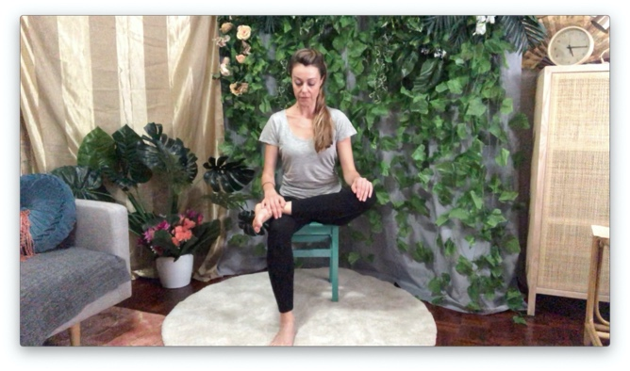
If available to you:

Lift your right ankle to sit on top of your left knee.
Keep your shin straight.
Feel the stretch in your right hip!

Release.

Repeat on the other side.

SEATED TWIST
Take your right hand to the outside of your left knee, and twist your torso to the left, resting your left hand on the back of the chair seat, turning your head to look behind you.
Take a few breaths here.
Release the head, then release the body to face the front / untwist.

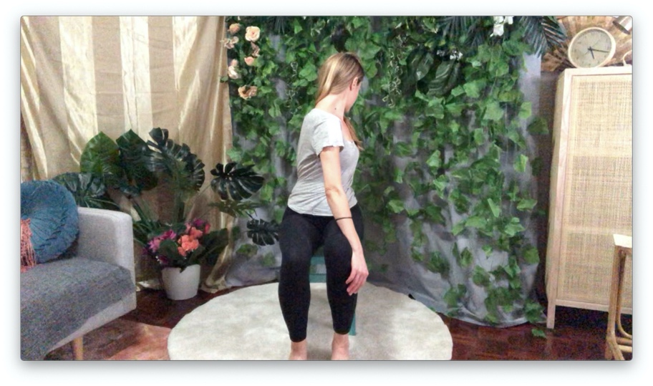

Now the other way!
Take your right hand to the outside of your right knee, twist your torso to the right, resting your right hand on the back of the chair seat, turning your head to look behind you.
Take a few breaths.
Release the head, then release the body to come back to the front.

Repeat on each side.

WHOLE BODY

SHAKE IT OUT
Shake, shimmy, release any knots or bits or bobs, have a good ol wriggle!

DEEP BREATHS
Take 3 deep breaths in and out, raising your arms to the sky for your in breath, and on the out breath bring your arms down to your sides or into prayer position at your chest.

WRIST STRETCHES
Strong tummies – lift your arms forward, straight line from the shoulders to finger tips

UNDER
Hands are flat, the palms facing up.
With your right hand, bend back the left fingers

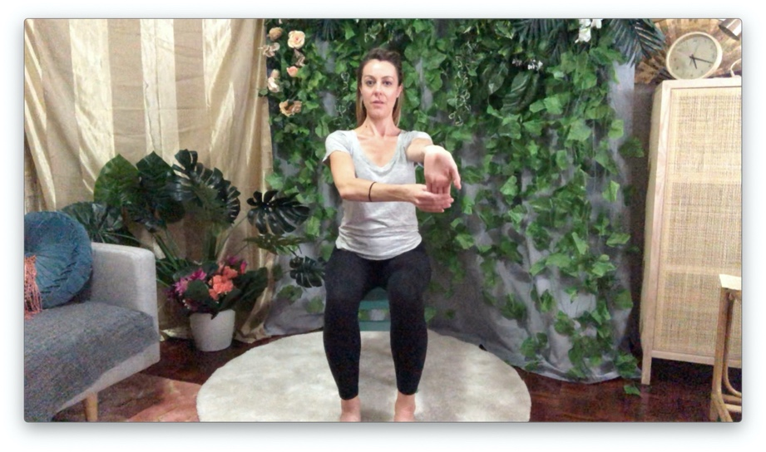

Swap – bend back your right fingers with your left hand

OVER
Keep your arms where they are, but twist your hands so that your palms are facing the floor
Use the left hand to pull down the right fingers

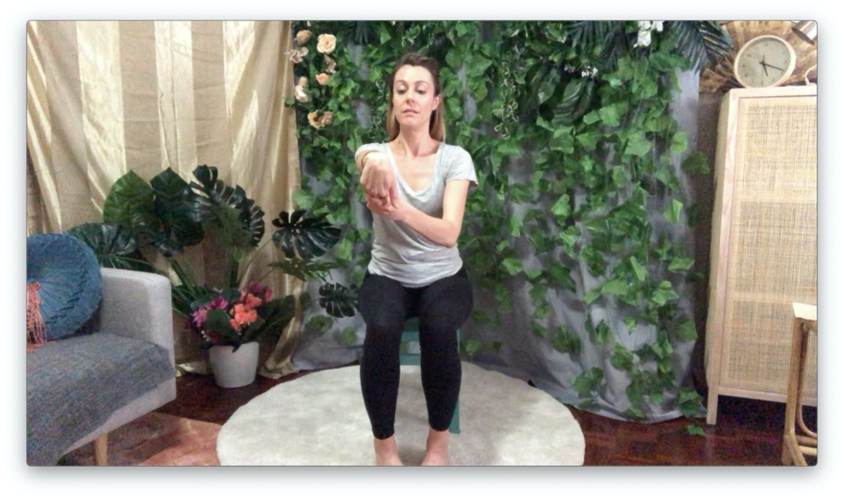

Swap – use the right hand to pull down the left fingers
Massage your forearms!

STRETCH
Keep your arms where they are, and turn your hands so that your palms are facing the front

Hold.
Breathe.

Keep your arms where they are, and bend your hands in at the wrists, like mini barn doors.
Open, shut, open, shut.

Now bend your arms in at the elbows, so that your hands come to rest in on your chest, and then open out again

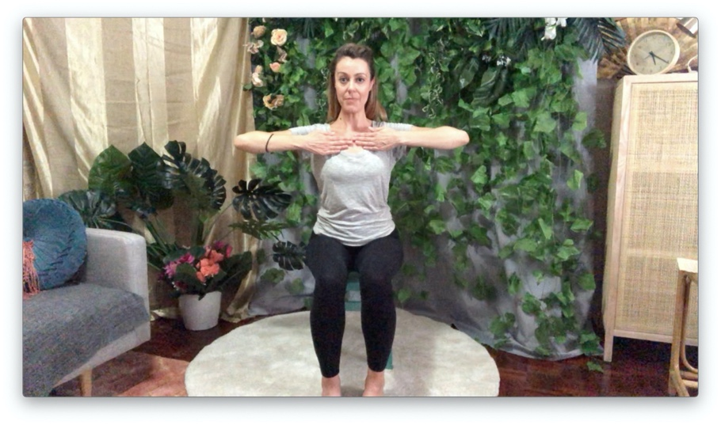

Release.

SHUT THE GATE
Bring your right arm out straight in front of you in line with your shoulder.

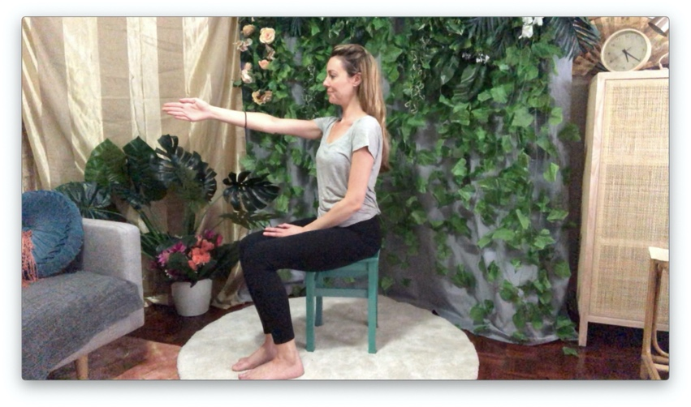

Bring your left hand around to the outside of your right elbow.

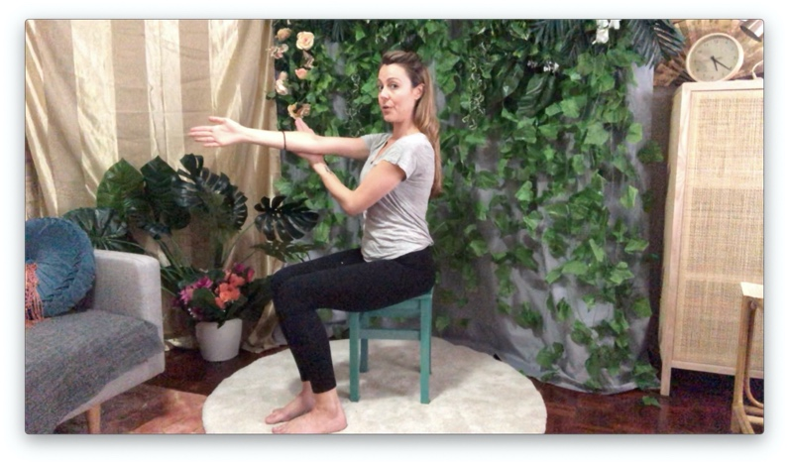
Gently use your left hand to guide your straight right arm across the front of your chest.

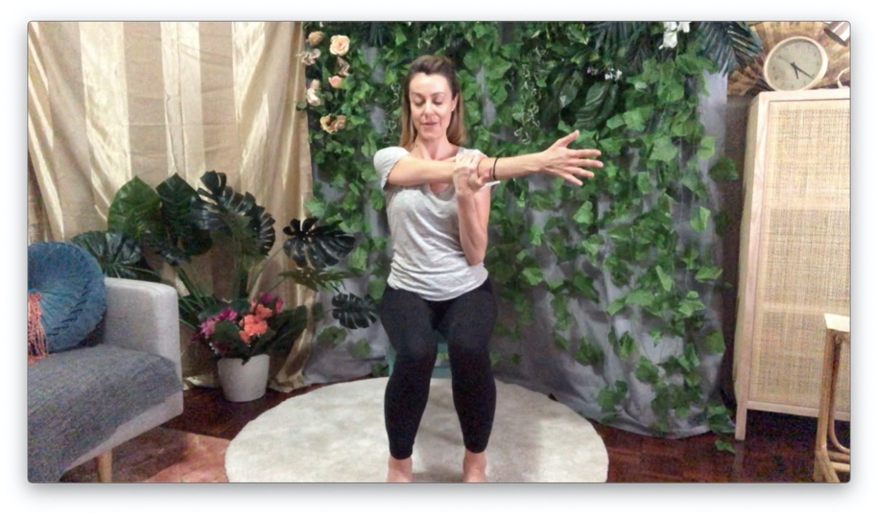

The aim here is to keep the arm straight, not to see how far you can reach your hand.
You should feel a little stretch behind your right shoulder, near the shoulder blade.

Repeat on the other side!

FINISHING UP
Stand up and take a forward bend, roll back up through the spine.
Shake it out!
Dust it off!

Well done

