Milk Crate Theatre Online Program 2020

BASICS SERIES – 01

BREATHING

Please only do what feels good for you here.
If breathing exercises or visualisations cause you anxiety rather than relaxation, then just skip this one for now.

GETTING INTO POSTURE

Sitting upright in a chair
Have a little wriggle and let out all of the little micro-tensions in your body.

Sitting on the edge of the chair, with your feet flat on the ground, hip-width distance apart
Knees above ankles, so your knees, ankles, and hips all make a nice bunch of right-angles!

Imagine there is a little string coming out from behind your belly button out of your back –
Imagine pulling that string, and pulling in your tummy.

You should immediately feel your body naturally sit up a little bit taller, and maybe your chest lifts a little too.
Gently roll your shoulders back a couple of times to open up the chest.

Hands on knees or thighs.

Sitting nice and tall, strong tummy but not exerting too much effort or being rigid about it.
Focus on your tummy strength and this will prevent building tension in your back.

Just feeling nice and strong and tall, from your bottom bones on the chair, up through your body to the tip of your head.

DIGNITY - This is a dignified and strong physical position!

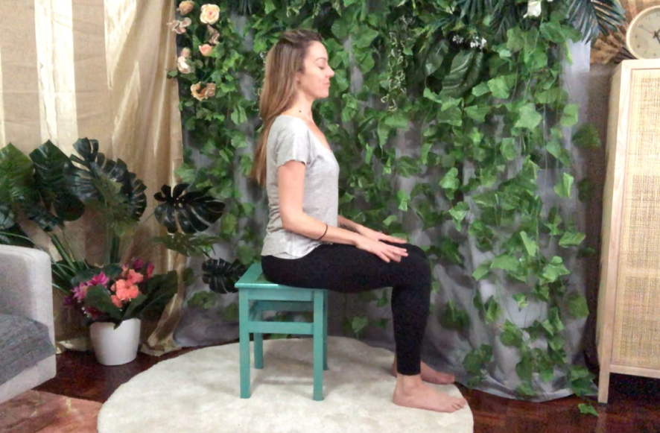

BREATHING

If you are sighted, let your eyes close, or pick a spot on the floor in front of you to focus your gaze onto – a soft little gaze.

And just breathe in and out.
That’s all!

Take notice of your breath coming in and out of your body.
Are you breathing quickly? Slowly? Are your breaths deep or shallow? Or a combination of all of these?
We are not judging our breath or trying to change it – just observing.
There’s no right or wrong.

So just breathe now for a little bit.

BODY SCAN
Take a scan of your body.
Are you feeling any fluttering or butterflies or tension?
No judgment, it’s all okay.

BREATH SCAN
Are you breathing in through your nose and out though your mouth?
Or in through your nose and out through your nose?
Both are good!

THOUGHTS and SOUNDS
You will hear noises around you, this is fine.
Thoughts may also come up, and this is completely normal and what the brain does. Whether the thoughts are good or bad, or if they’re about things you need to do, etc – just see if you can gently push them to the side.
Thank your brain for bringing them to your attention, but for now you’re just going to be breathing.
“Thanks brain! But for now I’m just going to be breathing.”

Gently sweep thoughts to the side.

AWARENESS
Become aware of the soles of your feet touching the floor.
Become aware of your buttocks or thighs in contact with the chair.
Reminder to keep belly button pulled in, and posture.

Keep breathing.

COLOUR
Think of a colour that feels vibrant to you, or soothing.
Eg yellow for energy, or pink for compassion

Imagine your breath is this colour.
With each breath, imagine this colour filling your lungs, and coming out clear
Each breath fills up more of your body – chest, torso, arms and legs, fingertips and toes

FINISHING UP
Check in with your body again, now that you have been breathing for a while.

Gently open your eyes.
Scan your surroundings and find yourself back in this physical space.

3 final breaths reaching arms up and out each time. Stretch!

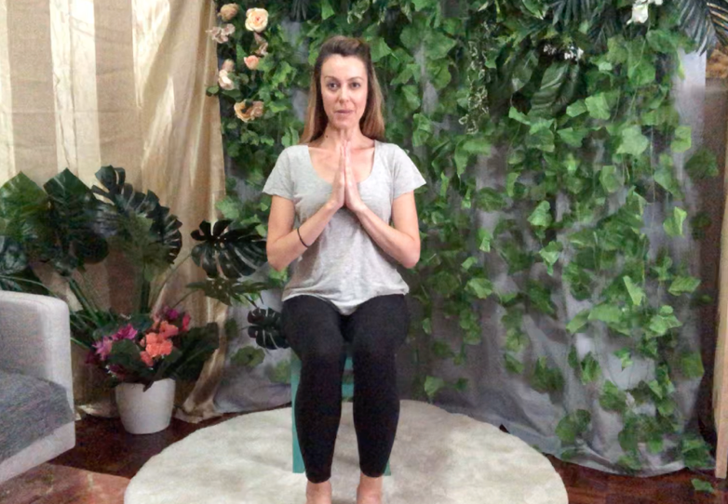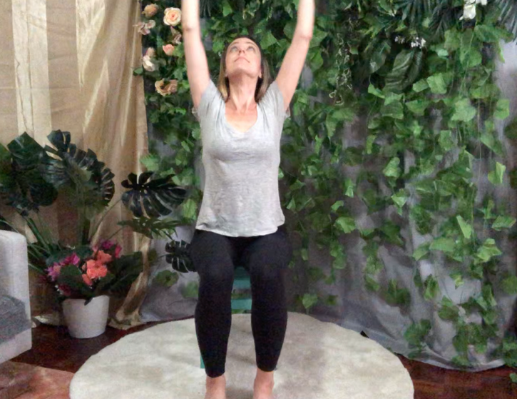

Well done

